Data Science Activity II

- Name: Pradeep Kumar Tiwari
- Semester: 5th
- Roll No: 152337

DataSet :- https://www.kaggle.com/datasets/uciml/iris
Dataset includes three iris species with 50 samples each as well as some properties about each flower. One flower species is linearly separable from the other two, but the other two are not linearly separable from each other.
The columns in this dataset are:
- Id
- SepalLengthCm
- SepalWidthCm
- PetalLengthCm
- PetalWidthCm
- Species
Since our objective is to find the optimal weights (parameters) and observe in how many epochs the single neuron converges, we simplified the dataset for training.
- Instead of using all three species, we selected only two species (to make the target variable binary).
- From the four available features, we chose only two features for simplicity:
  - SepalLengthCm
  - SepalWidthCm

So Initially , We have 150 rows and 6 columns , and after removing features we have 100 rows and 2 columns.

Data overview :-
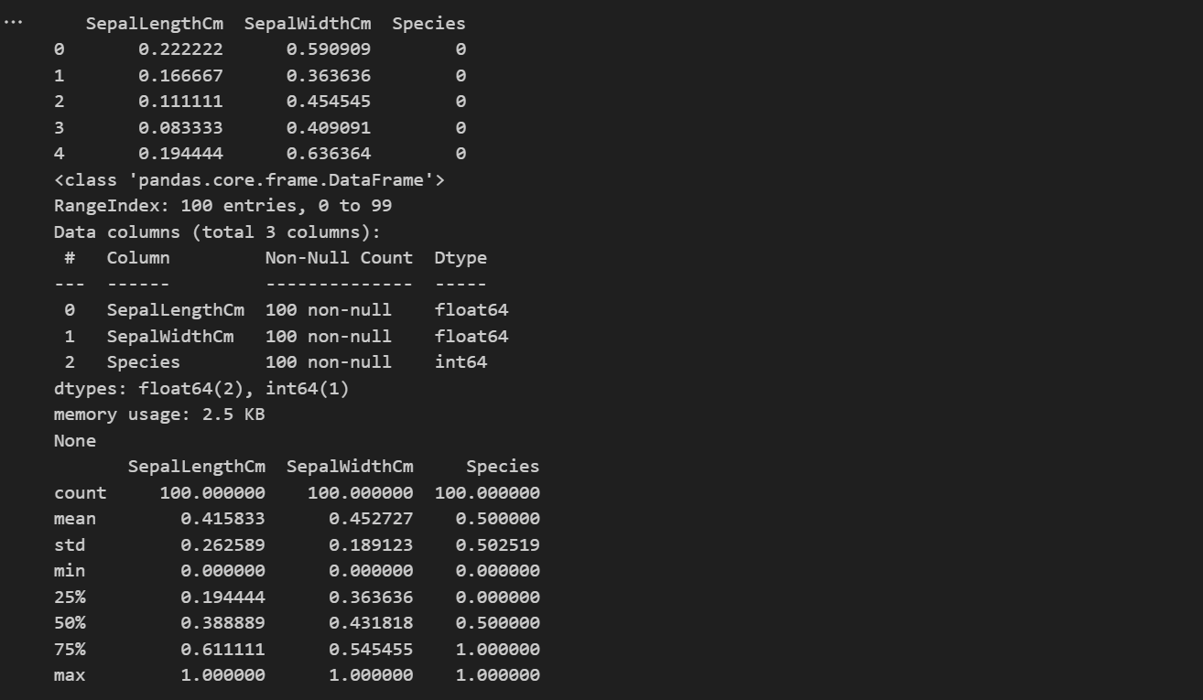

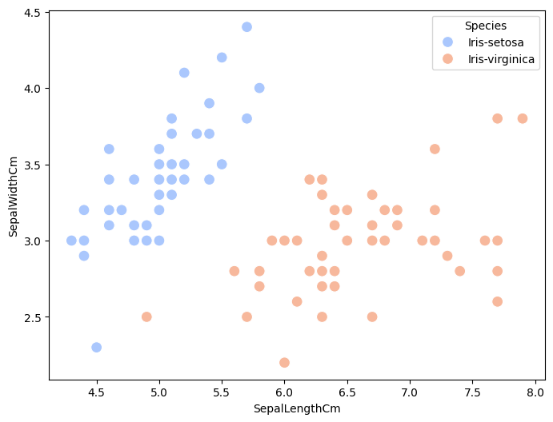
According to above graph, The data is linear seprable.

Activation Function :- Sigmoid Function
Learning Rate | Initial Weights  (w0, w1,w2) | x0 | Number of Epocs | Final Weights
1 | (0,0,0) | 1 | 143 | (-1,11.4445,-6.63637)
0.7 | (0,0,0) | 1 | 143 | (-0.7,8.01113,-4.64546)
0.5 | (0,0,0) | 1 | 143 | (-0.5,5.72224,-3.31818)
0.25 | (0,0,0) | 1 | 143 | (-0.25,2.86112,-1.65909)
0.25 | (3,3,3) | 1 | 10 | (-0.25,2.25,-0.875)
0.5 | (3,3,3) | 1 | 132 | (-0.5,5.73613,-3.34091)
0.7 | (3,3,3) | 1 | 93 | (-0.5,6.32501,-4.03183)
1 | (3,3,3) | 1 | 144 | (-1,11.4167,-6.59091)

Activation Function :- Step Fucntion
Learning Rate | Initial Weights  (w0, w1,w2) | x0 | Number of Epocs | Final Weights
1 | (0,0,0) | 1 | 143 | (-1,11.4445,-6.63637)
0.7 | (0,0,0) | 1 | 143 | (-0.7,8.01113,-4.64546)
0.5 | (0,0,0) | 1 | 143 | (-0.5,5.72224,-3.31818)
0.25 | (0,0,0) | 1 | 143 | (-0.25,2.86112,-1.65909)
0.25 | (3,3,3) | 1 | 10 | (-0.25,2.25,-0.875)
0.5 | (3,3,3) | 1 | 132 | (-0.5,5.73613,-3.34091)
0.7 | (3,3,3) | 1 | 93 | (-0.5,6.32501,-4.03183)
1 | (3,3,3) | 1 | 144 | (-1,11.4167,-6.59091)

Here both Activation Function gives Same Result.
Seprable line with weights :-
W0 = -1.11, w1 = 11.4445, w2 = -6.63637
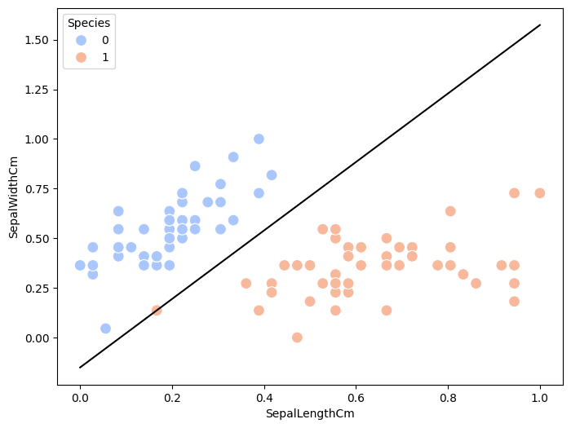

All Code material is available on github
https://github.com/Pktiwari12/Data-Science-class

